**PIZZA SALES SQL QUERIES**

**KEY PERFORMANCE INDICATORS (KPI’s)**

1. Total Revenue:

SELECT

SUM(total_price)

AS

Total_Revenue

FROM

pizza_sales;

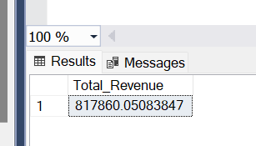

1. Average Order Value

SELECT

AVG(order_total)

AS

Avg_Order_Value

FROM (

SELECT order_id, SUM(total_price) AS order_total

FROM pizza_sales

GROUP BY order_id

)

AS

order_totals;

**OR**

SELECT

SUM(total_price) /

COUNT (DISTINCT order_id)

AS

Avg_Order_Value

FROM

pizza_sales;

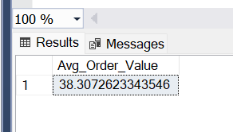

1. Total Pizza Sold

SELECT

SUM(quantity)

AS

Total_Pizza_Sold

FROM

pizza_sales;

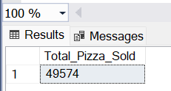

1. Total Order

SELECT

COUNT(DISTINCT Order_id)

AS

Total_Order

FROM

pizza_sales;

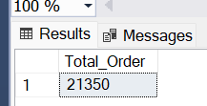

1. Average Pizzas Per Order

SELECT

CAST(

CAST(SUM(quantity) AS DECIMAL(10,2)) /

CAST(COUNT(DISTINCT order_id) AS DECIMAL(10,2))

AS DECIMAL(10,2))

AS

Ave_Pizza_Per_Order

FROM

pizza_sales;

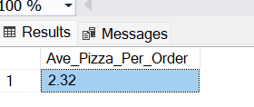

**CHART REQUIREMENT**

1. Daily Trend For Total Orders

SELECT

DATENAME(DW, order_date) AS order_Day,

COUNT(DISTINCT order_id) AS Total_Orders

FROM

Pizza_sales

GROUP BY

DATENAME(DW, order_date);

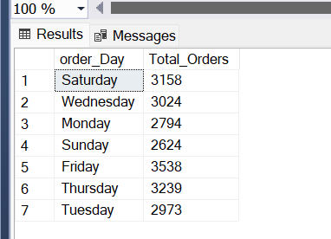

1. Hourly Trend For Total Orders

SELECT

DATEPART(HOUR, order_time) AS Order_Hour,

COUNT(DISTINCT order_id) AS Total_Orders

FROM

pizza_sales

GROUP BY

DATEPART(HOUR, order_time)

ORDER BY

Order_Hour;

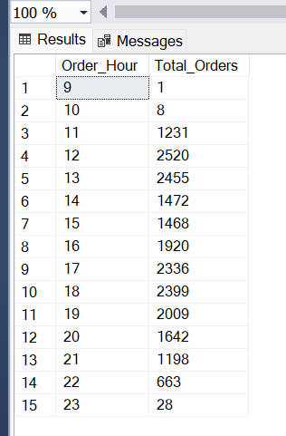

1. Percentage of Sales by Pizza Category

SELECT

pizza_category,

CAST(SUM(total_price) AS DECIMAL(10,2)) AS Total_Sales,

CAST(SUM(total_price) * 100 / (SELECT SUM(total_price) FROM pizza_sales) AS DECIMAL (10,2))

AS

PCT

FROM

pizza_sales

GROUP BY

pizza_category;

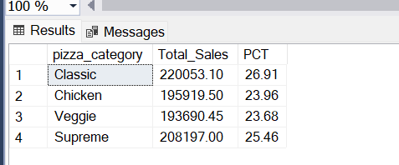

1. Percentages of Sales by Pizza Size

SELECT

pizza_size,

CAST(SUM(total_price) AS DECIMAL(10,2)) AS Total_Sales,

CAST(SUM(total_price) * 100 / (SELECT SUM(total_price) FROM pizza_sales) AS DECIMAL (10,2))

AS

PCT

FROM

pizza_sales

GROUP BY

pizza_size

ORDER BY

PCT

DESC ;

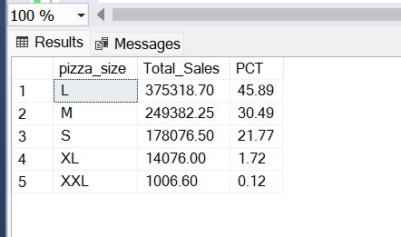

1. Total Pizza Sold by Prize Category

SELECT

pizza_category, SUM(quantity)

AS

Total_Pizzas_Sold

FROM

pizza_sales

GROUP BY

pizza_category ;

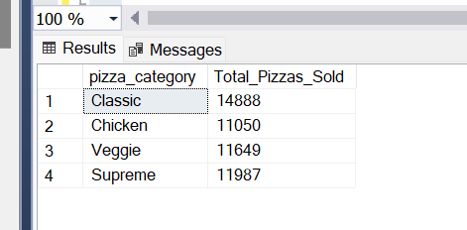

1. Top 5 Best Sellers by Total Price Sold

SELECT TOP 5 pizza_name,

SUM(quantity)

AS

Total_Pizzas_Sold

FROM

Pizza_sales

GROUP BY

pizza_name

ORDER BY

SUM(quantity)

DESC ;

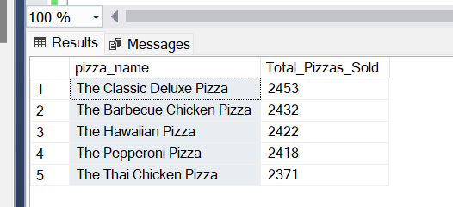

1. Bottom 5 Worst Sellers By Total Pizzas Sold

SELECT

TOP

5 pizza_name,

SUM(quantity)

AS

Total_Pizzas_Sold

FROM

Pizza_sales

GROUP BY

pizza_name

ORDER BY

SUM(quantity)

ASC ;

